

Internal Audit – Budgeting and Reporting

Process Understanding Document

Prepared by | Rakesh Amin / Musab Ali Daqa
Date | 9 September 2023

Budgeting and Reporting Section Overview
The Budgeting Section is currently a separate section under the Finance Department headed by VP Finance and Business Development. The key responsibilities of the Budgeting section include the following:
- Develop and maintain capital and operating budgeting process, including budget requirements for planning entities.
- Develop guidelines for capital allocation, revenue planning and capital allocation processes.
- Maintain capital projects budget.
- Periodic reporting to Department of Finance (DoF) as required.

The main purpose of the Budgeting Section is to oversee the university’s budget development and control process while delivering accurate and timely reporting to Management on the up-to-date budget status (Budget vs. Actual).
The activities undertaken by the Budget Section cover several types of activities such as: budget interpretation, communication & guidance, budget collection & development, budget assessment & prioritization, budget finalization & approval and budget monitoring & control.

Budgeting and Reporting Section Structure
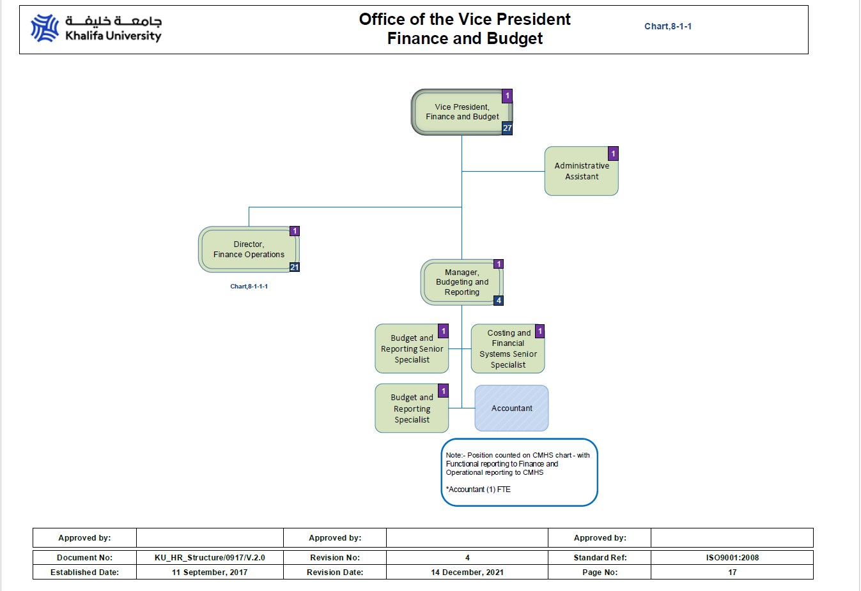

The organization structure for the Budgeting & Reporting Section at KU has 5 positions available as per the approved organization chart as follows:
- Manager, Budgeting and Reporting
- Budgeting and Reporting Senior Specialist
- Budgeting and Reporting Specialist
- Costing and Financial Systems Senior Specialist
- Accountant

However, the current staff of the Budgeting and Reporting Section are as follows:
Sr No | Name | Designation
1 | Abdulla Ali Al Mansoori | Manager, Budgeting and Reporting
2 | Al Anood Al Khoori | Budget and Reporting Senior Specialist
3 | Eiman Al Khoori | Budget and Reporting Specialist
4 | Mushtaq Mohammed Sheriff | Costing and Financial Systems Senior Specialist
5 | Fatema Al Mazrooei | Accountant

Policies and Procedures
- There is one policy available for budget process under the Finance Department
Sr No | Policy Name | Policy Description | Approval Date
1 | KUP 6000 Budgeting Policy | Budget preparation, approval, and monitoring | Approval pending
2 | KUP 6000 Budgeting Procedures and Guidelines | Budget preparation and consolidation, amendment, monitoring & reporting | March 13, 2023

There are budget guidelines available which are sent to the end users during the budget preparation process. Further, the budgeting procedures and Delegation of Authority defines the framework for the budgeting process.

As per Budgeting Policy No. KUP 6000, Section 7 “The policy document is reviewed once every four (4) years, or when special circumstances dictate a review”. This policy was disseminated on 01 January 2018 and the scheduled review date was 01 January 2022 for the KUP 6000 policy document; however, it was reviewed on 01 February 2023 but the approval is yet to be obtained.

Committees involved in the Budgeting Process

Budget Committee: - The current Budget Committee is a sub-committee of the Board for KU’s Budgeting process.

As per KUP 6000 Budgeting Policy, the purpose of the Budget Committee is to advise the president on budgetary matters and recommend a budget for presentation to the Board of Trustees. More specifically, the role of the Budget Committee is to:
- advise the president on budget policy and financial planning;
- recommend enrollment targets and funding levels;
- recommend principles, policies, and procedures to address budgetary issues;
- advise on significant disparities or imbalances between and among budgetary units and recommend remedial adjustments;
- recommend to the president a budget for presentation to the Board of Trustees.

Approved Budget for 2022
The Financial ceiling for 2022 was communicated by DoF on 23-Dec-2021 & for 2023 was communicated on 12-Jan-2022.
Sr No | Expenses | 2022 | 2023
1 | Personnel Budget (Chapter 1) | 610,207,000 | 677,000,000
2 | Operating expenses (Chapter 2) | 592,955,000 | 712,000,000
3 | Capital expenditures (Chapter 3) | 110,301,000 | 160,800,000
Total Expenses |  | 1,313,463,000 | 1,549,800,000

Total expected revenue of KU for 2022 was 66,229,000 AED and for 2023 is 44,607,000 AED
Subject | 2022 | 2023
Revenue | 66,229,000 | 44,607,000

The total budget versus actual as per “2022 Budget vs Actual Report” are as follows:
Sr No | Chapter wise | Total Budget Amount (AED) | Total Revised Budget Amount (AED) | Total Actual Amount (AED)
1 | Personnel Budget (Chapter 1) | 610,207,000 | 615,263,864 | 609,549,813
2 | Operating expenses (Chapter 2) | 592,955,000 | 579,850,000 | 560,743,682
3 | Capital expenditures (Chapter 3) | 110,301,000 | 110,301,000 | 104,300,172
Total |  | 1,313,463,000 | 1,305,414,864 | 1,277,147,381
The total number of budget transfers made in 2022 was 205 transactions with an amount of AED 238,868,706. Below is a table summarizing the number and amount of transfers made in 2020, 2021, 2022, and 2023 based on chapter wise.
Sr No | Chapter wise | 2019 | 2022 | 2023 (up to 16-Oct-23)
1 | Personnel Budget  - Number of Transfers  - Amount of Transfers |  | 65  81,854,104 | 60  74,290,819
2 | Operating expenses
 | - Number of Transfers |  | 112 | 75
 | - Amount of Transfers |  | 124,211,394 | 85,864,732
3 | Capital expenditures
 | - Number of Transfers |  | 28 | 19
 | - Amount of Transfers |  | 32,803,208 | 22,648,979
 | Total
 | - Number of Transfers | 81 | 205 | 154
 | - Amount of Transfers | 110,315,685 | 238,868,706 | 182,804,530

Budget Preparation, Consolidation and Reporting

- On an annual basis based on the guidelines received from DoF, the Budget team prepares the templates and guidelines required for the budgeting process.
- The budget is classified into three categories:
  - Personnel Budget (Chapter 1),
  - Opex Budget (Chapter 2) and
  - CAPEX (Chapter 3).
- At the time of Budget Announcement Budget guidelines, accompanied by budget templates, are sent to user departments.
- There are two different budget templates sent to the budget owners.
  - For Personnel Budget – This template would be circulated by HR. The budget owners would need to fill them up and send them directly to HR.
  - For Operating and Capital budgets – This template would be circulated by Finance. The budget owners would need to fill them up and send them to the Budget department
- A workshop is held by the budget team for the departments concerned with filling out the budget form, to discuss what is required and answer any inquires/ questions they have before starting to fill out the budget templates.
- Once the budget templates are sent by the user departments, the budget team validates the budget and the budget team requests supporting documents from the end users.
- Once the budget is finalized the budget is consolidated manually in excel sheets and discussed with the SVP, VP and EVP.
- The finalized budget is also discussed with the Board Executive committee chaired by the Minister of Education
- The budget is also sent to the Board of Trustees for approval (through email or meetings).
- The Final budget is sent to the Department of Finance through an official letter signed by the President/EVP informing the finalized budget along with supporting documents.
- The approved Budget is informed by the DOF and the budget is uploaded by the Budget team in the Hyperion.
- Once DoF has approved the budget, the budget is available in the system as proposal version and then it is given in the distributed version in the system. The budget is checked and submitted again in the Hyperion in the DoF and then it is updated in the ADERP system against each cost centre and account code. The budget team takes 1 week for review, validate and reconciling the budget figures. Further there is a capping amount per chapter which is checked at the proposal version.
- The Final Budget approved by DoF is informed by the Budget team to the Department heads.

Sr. No | Description | Endorse Review | Approve
1 | Budget & its Amendments | BoT | Executive Council (EC)

- As per the Delegation of Authority (DoA) matrix, the Budget must be reviewed and endorsed by the BoT before sending it to DoF, but sometimes, to avoid delay, it is sent to DoF directly without being presented to the BoT for review and endorsement because there is no Board meeting in that period, and it is presented to the Board at its next meeting.

Budget Transfers / Reallocation:

- The Budget transfers / reallocations are initiated in the E-services portal.
- The approvals are initiated as per the workflow in the system and as per the Delegation of Authority.

Sr. No | Budget Transfer | Endorse Review | Approve
1 | Between Chapters | BFIC | BoT (As per EC guidelines)

Sr. No | Budget Reallocation within Chapter | Endorse Review | Approve
1 | Up to 1,000,000 AED | VP Finance | Head of Finance
2 | 1,000,000 – 2,500,000 AED | Head of Finance | President
3 | 2,500,000 – 10,000,000 AED | President, Head of Finance | EXCOM
4 | Above 10,000,000 AED | EXCOM, President, Head of Finance | BoT

Key Points from Budget Guidelines
- The budget activities are classified as strategic new initiatives and regular operations for the year 2023. The budget template column, namely the 2023 Budget Activity Type, selects the appropriate value to emphasize the regular & new initiatives.
- The budget should be linked to the university's strategic & departmental operational objective. While preparing the budget, template should filled and strategy & correct department objective to be filled in a respective column for each budget account line.
- The management requested to prepare the budget proposal with another three scenarios, to make the budget preparation process & budget allocation to be more efficient. There are three columns in the template for the 2023 budget proposal as 90% (10% Deduction), 80% (20% Deduction), 70% (30%Deduction), and each of them should fill up accurately with impact & justification, if the DoF come up with reduction in the budget, one the most relevant scenario will be selected.
- The externally funded research projects are not included in the Budget submission.
- Any Purchase Order that is issued in 2022 is expected to be received/ services availed during 2022. No budget carry forward for open Purchase order from 2022 to 2023 is permitted.

Manpower Budget Guidelines
HR department provides a manpower budget template for each individual Academic, Research and Administrative sector. The sectors are expected to submit their manpower budget to HR, within the submission deadline, communicated by HR. Graduate student stipends & Research personnel costs (post docs, research associates, research assistants, research temps, visiting research grad students) are to be considered in operating budget category. In such cases, headcount, tenure of service and itemized monthly cost must be provided. After finalizing the list of positions, HR shall fill the Hyperion system with the final list of positions, along with the costing elements (earnings and benefits).

Operating Budget Guidelines
Estimated annual expenditures should be entered onto the Operational Budget template for the accounts that have been allocated to the individual budget owners departments / units. The 2023 to 2025 estimates should be arrived after evaluating department activities, needs and new initiatives, which should be aligning it with the University strategy and policy.
- For some account lines, a content expert has been identified to review the align the proposal with KU process and remove any duplication.
- For some account lines, detailed computations/calculations/breakdown in the designated template is required.
- Research expense: Detailed breakdown listing the method of calculation is to be submitted which should include the breakdown by expenditure type and also to provide the number of the resources/ staff and it’s rate. If the budget is made against one general research account, the detailed breakdown between different components should be provided in the itemized sheet.
Capital Budget Guidelines
Capital equipment is defined with a value of AED 5,000 or greater and that has a life expectancy beyond one year (not considered a consumable). Capital equipment is to be summarized on the equipment template according to the following categories:

• General Equipment: Plant & Equipment; Office Equipment; Teaching Equipment; Lab Equipment
• Furniture and Fixtures
• IT Equipment and Software
• Vehicles
• Buildings: New Buildings; Building Improvements

The Capital Equipment estimates for 2023 should be arrived at by aligning it with the Academic, Research or Institutional requirement of the University.

Revenue Budget Guidelines
Business Development (BD) unit is responsible for planning and growth of KU revenues:
Student Services department liaises with BD unit for budgeting revenue from student sponsorship, tuition fees, accommodation, transportation, etc.). Rental revenue from agreements shall be projected by VP/Administration, Facilities, EHS in association with Procurement and then to be submit to Business Development section. And after the Business Development section review all revenue then will endorse it to Budget section.

Reporting

- On a quarterly basis, Budget vs Actual Report is sent to DoF after the GL closing is done for closing the accounting period.
- On a weekly basis in 2022, an automated email sent by the Business Intelligence module in ADERP to the end users.

Budget Timelines as per Budget Announcement for FY 2023

Sr. No | Activities | Timelines
1 | Circulate guidelines and templates | By 22 April 2022
2 | Workshop & Inquiries | By 28 April 2022
3 | Get Filled Templates from budget owners | By 07 June 2022
4 | HR Manpower Plan | By 07 June 2022
5 | Consolidation, review, meetings and update with budget owners | By 29 June 2022
6 | Management & Board of Trustees will review and approve | By 15 July 2022
7 | Submission to DoF | By 29 July 2022

Budget Checks
- The ADERP system has absolute control in reviewing the budgetary limits of each account code. The PR/Invoice processing are initiated if there are sufficient funds available in the account codes.
- If sufficient funds are not available to initiate the transaction, then fund issues are shown and the transactions cannot be completed unless a budget transfer is initiated.
- There are DoF restrictions regarding fund transfer between Chapters and approval from EC needs to be obtained for such transfers.
- During the year, there is a new process of cancelling old PRs during the last week of December each year. For all cancelled PRs and unreserved POs, a new PR needs to be raised in the next year.

Provisional budget earmarked for unforeseen events (Emergency readiness)
- Currently there is no dedicated budget allocated for addressing unforeseen events, particularly for bolstering emergency readiness. Without such a budget, the organization may face challenges in allocating resources promptly and efficiently during unexpected situations. This could potentially hinder the University’s ability to respond effectively and safeguard the continuity of critical operations.
- We were informed that creation of a provisional budget is not practical considering the guidelines laid down by DoF.

